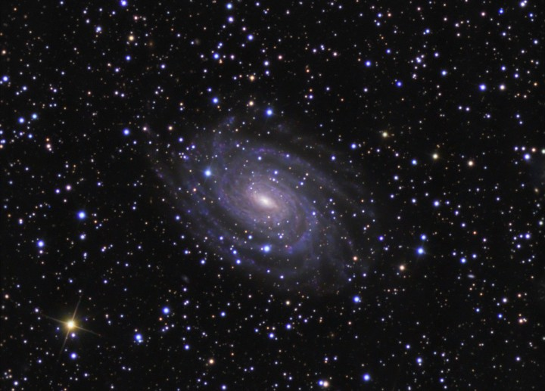
Topics Reviewed:
Analyzing Rock Layers
Fossils
Geologic Events
Evolution of Life
Radioactive Dating

PLUS 27 Practice Regents Questions with Answers
Earth Science
Regents Review #8
Geologic History
© Kaitlin Coder
https://www.teacherspayteachers.com/Store/Nys-Earth-Science-And-Living-Environment-Regents
Regent Review #8
Geologic History

- Determining Relative Age
  - Geologic history can be reconstructed by observing sequences of rock types and fossils to correlate bedrock at various locations.
    - Age relationships among bodies of rocks can be determined using principles of:
      - Original horizontality: sedimentary rock layers are formed in flat, horizontal layers
      - Superposition: the lowest layer in a rock sequence was formed first and is oldest. Each successive layer above it formed after and is younger. (unless the rock layers have been overturned)
      - Cross-cutting relationships: any faulting or folding that affects rock layers had to have happened after those rock layers formed, and thus the rock layers would be older than the faulting or folding.
      - Contact metamorphism: if contact metamorphism occurs, that rock layer existed and is older than the igneous intrusion
      - Unconformities: rock layers can be eroded away. This is indicated by a wavy line between rock layers and indicates a gap in the geologic record.
    - The presence of volcanic ash layers and index fossils can provide additional information because they occurred over a wide area in a short time period.
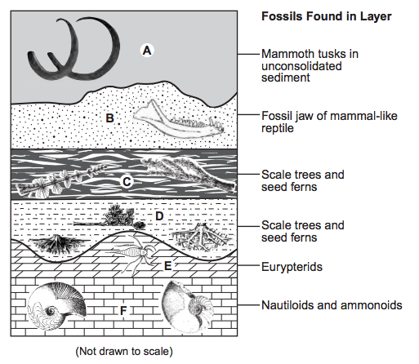
  - The characteristics of rocks indicate the processes by which they formed and the environments in which these processes took place.
    - Landforms are the result of the interaction of tectonic forces and the processes of weathering, erosion, and deposition.
    - Plate motions have resulted in global changes in geography, climate, and the patterns of organic evolution.
    - Fossils preserved in rocks provide information about past environmental conditions.
  - Geologists have divided Earth history into time units based upon the fossil record. (ESRT pages 8-9)

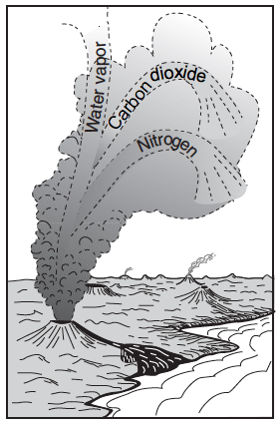
- Evolution of Life
  - Earth’s early atmosphere formed as a result of the outgassing of water vapor, carbon dioxide, & nitrogen from volcanic eruptions.
  - Earth’s oceans formed as a result of precipitation over millions of years. The presence of an early ocean is indicated by sedimentary rocks of marine origin, dating back about four billion years.
  - The evolution of life caused dramatic changes in the composition of Earth’s atmosphere.
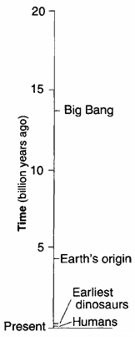
    - Free oxygen did not form in the atmosphere until oxygen-producing organisms evolved.
  - The pattern of evolution of life-forms on Earth is at least partially preserved in the rock record.
    - Fossil evidence indicates that a wide variety of life-forms has existed in the past and that most of these forms have become extinct.
    - Human existence has been very brief (less than 1%) compared to the expanse of geologic time.

- Radioactive dating
  - The regular rate of nuclear decay (half-life) of radioactive isotopes allows geologists to determine the absolute age of materials found in some rocks. (ESRT page 1 Radioactive Decay Data)
    - Uranium-238 has a half-life nearly equal to the age of Earth & our solar system.
    - Carbon-14 has a very short half-life and is used to date recent living objects (within the past 50,000 years).
    - Potassium-40 dates old rocks and old fossils
    - The half-life of a radioactive element can't be changed.
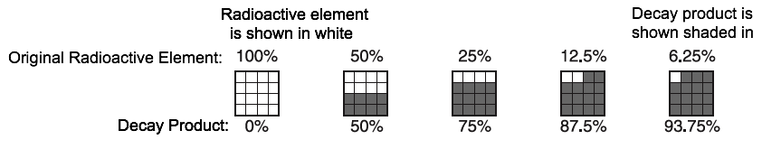

Regents Review #8
Earth’s History

Practice Regents Questions

- Scientists infer that most of Earth’s earliest atmosphere was produced by
(1) a collision with a giant gas cloud
(2) capturing gases from a nearby planet
(3) vaporizing comets that impacted Earth’s surface
(4) the escape of gases from Earth’s molten surface

- What percentage of Earth’s history represents human existence?
(1) less than 1.0% (2) 1.8% (3) 23.5% (4) more than 98.6%

- During which period in geologic history did the uplifting of the Adirondack Mountains begin?
(1) Quaternary (2) Cretaceous (3) Triassic (4) Cambrian

- The graph below shows the decay of a radioactive material over time.
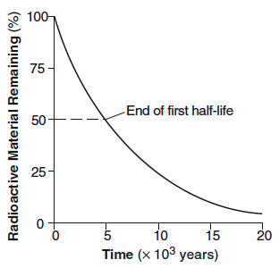
How long does it take for this radioactive material to decay through 2 half-lives?
(1) 1 x 10³ years (3) 10 x 10³ years
(2) 5 x 10³ years (4) 40 x 10³ years

- A 65.5-million-year-old impact crater in Mexico provides evidence for the cause of the
(1) breakup of Pangaea
(2) evolution of the earliest corals
(3) Alleghenian orogeny
(4) extinction of ammonoids

- When did the earliest humans appear on Earth?
(1) before the earliest dinosaurs
(2) before the earliest flowering plants
(3) during the Pleistocene Epoch
(4) during the Late Triassic Epoch

- Which scientific principle states that younger rock layers are generally deposited on top of older rock layers?
(1) superposition (2) evolution (3) original horizontality (4) inclusion

- Which pie graph best shows the relative length of time of the major intervals of Earth’s geologic history?
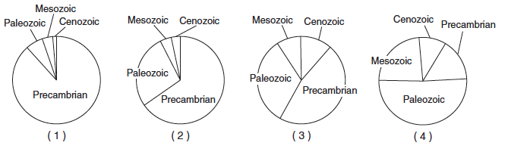
- The cross sections below represent three widely separated bedrock outcrops labeled A, B, and C. Letters W, X, Y, and Z represent fossils found in the rock layers.
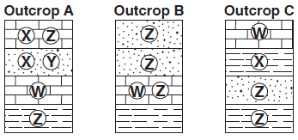
Which fossil could best be used as an index fossil?
(1) W (2) X (3) Y (4) Z

Base your answers to questions 10 and 11 on the block diagram below, which shows bedrock units
A through F and boundary XX’.
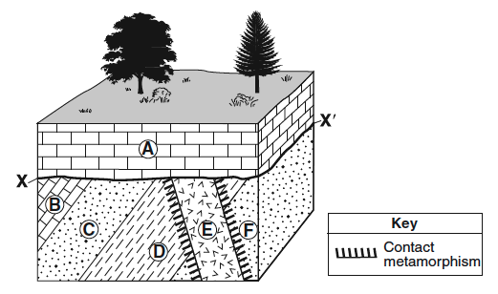
- The rock that formed in the contact metamorphic zone between rock unit E and rock unit D is
(1) hornfels (2) marble (3) schist (4) anthracite coal

- Which sequence best describes the geologic history, from oldest to youngest, that occurred at this site?
(1) deposition of F, D, C, B → intrusion of E → uplift and erosion → deposition of A
(2) intrusion of E → deposition of F, D, C, B → uplift and erosion → deposition of A
(3) deposition of F, D, C, B, A → uplift and erosion → intrusion of E
(4) deposition of F, D, C, B, A → intrusion of E → uplift and erosion
Base your answers to questions 12 through 14 on the geologic cross section and photograph below and on your knowledge of Earth science. The cross section represents the Palisades sill in southern New York State and the surrounding bedrock. Potassium-40 analysis determined the sill to be approximately 200,000,000 years old. The photograph shows a mastodont tooth found in glacial sediments nearby. Carbon-14 analysis determined this tooth to be approximately 11,400 years old.

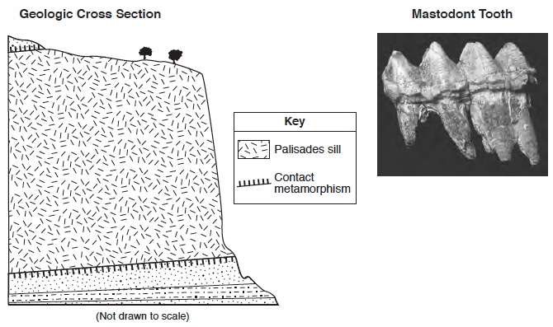

- Which metamorphic rock was most likely produced in the contact zone between the Palisades sill and the sedimentary rock?
(1) schist (2) slate (3) gneiss (4) quartzite

- Potassium-40 is useful for radioactive dating of the Palisades sill because the half-life of potassium-40
(1) decreased as the amounts of 40-Ar and 40-Ca in the sill increased
(2) remained constant during the radioactive decay process
(3) increased as pressure from the overlying sedimentary rock increased
(4) was shortened by the high temperature of the magma that formed the sill

- The mastodont tooth and the entire Palisades sill represented above are similar in that both
(1) can be found in deposits left by the last continental ice sheet in New York State
(2) are fossils of animals that once lived in New York State
(3) can be used as time markers to date nearby geologic events
(4) are Mesozoic in age

Base your answers to questions 15 through 18 on the cross section below and on your knowledge of Earth science. The cross section represents rock units that have not been overturned. Lines CC’ and GG’ represent unconformities. The geologic ages of some of the lettered rock units are shown below the cross section.
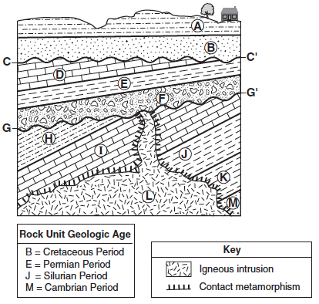
- Which rock unit was formed most recently?
(1) A (2) F (3) L (4) M

- Why is there no contact metamorphism indicated between rock unit L and rock unit F?
(1) Conglomerate does not metamorphose.
(2) The intrusion was not hot enough to metamorphose rock unit F.
(3) The contact metamorphism within rock unit F eroded away.
(4) Rock unit F was deposited after the intrusion of rock unit L.

- The diagrams below represent three index fossils found in one of the rock units.
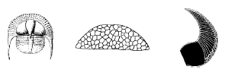
These fossils are most likely found in
(1) rock unit I (2) rock unit J (3) rock unit K (4) rock unit M

- Which inference about rock units D, E, and H can best be supported by evidence in the cross section?
(1) They contain mostly sand-sized sediment.
(2) They contain both land and marine fossils.
(3) They were altered by contact metamorphism.
(4) They were deposited as horizontal layers and were later tilted.

Base your answers to questions 19 and 20 on the partial geologic map below and on your knowledge of Earth science. The map shows the geographical distribution of most of the Devonian-age surface bedrock in New York State.

- On the map, place an X at a location where the gastropod fossil Platyceras might be found in the surface bedrock.
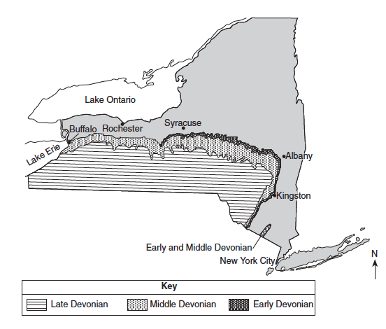

- State the name of the New York State landscape region that includes most of the Devonian-age surface bedrock shown on the map.

Base your answers to questions 21 through 23 on the cross section in your answer booklet and on your knowledge of Earth science. The cross section represents several geologic structures. Line AB represents a fault. C and D represent rock units.
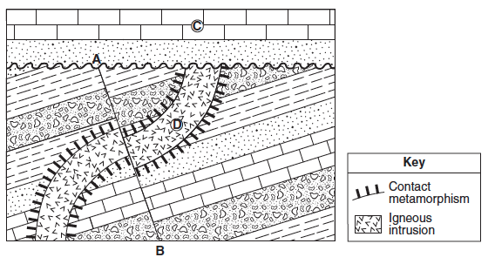

- On the cross section above, place an X on the unconformity.

- On the cross section above, place two arrows, one on each side of fault AB, to show the relative movement of the rock units on each side of the fault.

- Indicate the proper sequence of the geologic events listed below by writing the number 1 after the first event, the number 2 after the second event, and the number 3 after the last event.

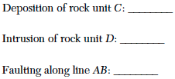

Base your answers to questions 24 through 27 on the cross sections below and on your knowledge of Earth science. The cross sections represent three bedrock outcrops, 1, 2, and 3, found several kilometers apart. The geologic time period when each sedimentary rock layer formed is shown. The symbols represent fossils of different types of organisms present in the rock layers.

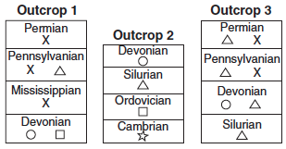

- Draw the fossil symbol that represents the best index fossil. Describe one piece of evidence shown in the outcrops that indicates that this fossil has characteristics of a good index fossil.

- Write the outcrop number of the cross section that could be found in New York State. Describe the evidence that supports your answer.

- Explain why the geologic age of these rock layers could not be accurately dated using carbon-14.

- Explain why the index fossil Coelophysis is not preserved in any of the rock outcrops.

Regents Review #8
Earth’s History

Practice Regents Questions – Answer Key

- 4 (See Fact 30a)
- 1 (See Fact 30d,ii)
- 2 (See ESRT pages 8-9)
- 3 (See Fact 31a)
- 4 (See ESRT pages 8-9)
- 3 (See ESRT pages 8-9)
- 1 (See Fact 29a,i)
- 1 (See ESRT pages 8-9)
- 1 (See Fact 29a,ii)
- 1 (See ESRT page 7 – Sedimentary Rocks AND Metamorphic Rocks)
- 1 (See Fact 29a,i)
- 4 (See ESRT page 7 – Sedimentary Rocks AND Metamorphic Rocks)
- 2 (See Fact 31a,iv)
- 3 (See Fact 29a,ii)
- 1 (See Fact 29a,i)
- 4 (See Fact 29a,i,4)
- 3 (See ESRT pages 8-9)
- 4 (See Fact 29a,i,3)
- Allow 1 credit if the center of the X is within the Middle Devonian zone or the Early and Middle Devonian zone located northwest of New York City. (See ESRT pages 8-9)
- Alleghany Plateau (See ESRT page 2)
- Allow 1 credit if the center of the X is placed on or near the unconformity (wavy line) within the region indicated in the diagram below. (See 29a,i,5)
- Allow 1 credit for the correct placement of both arrows as shown below.
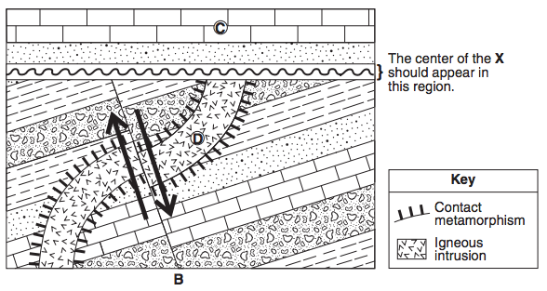

- (See Fact 29a,i)
Deposition of rock unit C: 3
Intrusion of rock unit D: 1
Faulting along line AB: 2
- O. This fossil existed for a short time (Devonian) and was found over a wide area (in all 3 outcrops). (See Fact 29,a,ii)
- 2. The Permian period is not found in the NYS Rock Record. (See ESRT pages 8-9)
- Carbon-14 has a short half-life. These rock layers are very old. (See 31a,ii and ESRT page 1 – Radioactive Decay Data)
- Coelophysis lived during the Triassic period which is not one of the rock layers in the outcrops. (See ESRT pages 8-9)

