Topics Reviewed:
Weathering, Erosion & Deposition
Mass Movement
Wind
Ocean Waves
Glaciers
Running Water
Landscapes & Stream Drainage Patterns

PLUS 25 Practice Regents Questions with Answers
Earth Science
Regents Review #6
Surface Processes
© Kaitlin Coder
https://www.teacherspayteachers.com/Store/Nys-Earth-Science-And-Living-Environment-Regents
Regents Review #6
Surface Processes
- Weathering
  - Weathering is the physical and chemical breakdown of rocks at or near Earth’s surface.
    - Acid rain dissolves bedrock composed of calcite (limestone; marble).
  - Soils are the result of weathering and biological activity over long periods of time.
- Erosion & Deposition
  - Erosion: Natural agents of erosion, generally driven by gravity, remove, transport, and deposit weathered rock particles.
  - Deposition: Patterns of deposition result from a loss of energy within the transporting system and are influenced by the size, shape, and density of the transported particles. Sediment deposits may be sorted (vertically or horizontally) or unsorted.
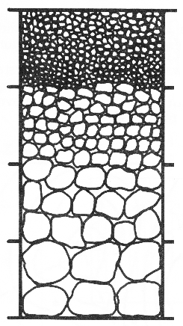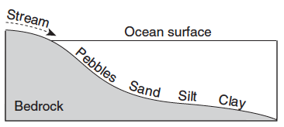
  - Factors affecting erosion & deposition: each agent of erosion produces distinctive changes in the material that it transports and creates characteristic surface features and landscapes.
    - Mass movement: Earth materials move downslope under the influence of gravity resulting in unsorted, angular sediments.
    - Wind: Erosion of small sediments by wind is most common in arid climates and along shorelines.
      - Wind-generated features include dunes and sand-blasted bedrock.
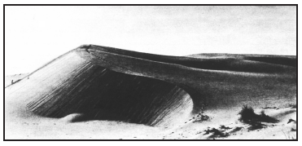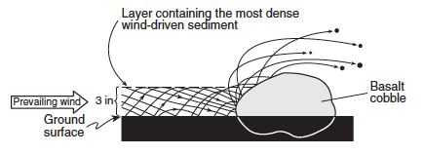
    - Ocean Waves Erosion and deposition cause changes in shoreline features, including beaches, sandbars, and barrier islands. Wave action rounds sediments as a result of abrasion. Waves approaching a shoreline move sand parallel to the shore within the zone of breaking waves.
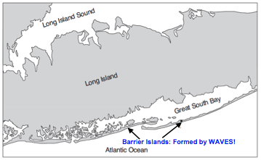
    - Glaciers: Glacial erosional processes include the formation of U-shaped valleys, parallel scratches, and grooves in bedrock.
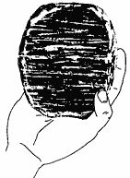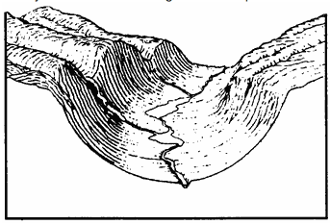
      - Glacial features include:
        - Moraines: mound of unsorted, unlayered sediments deposited by the edge of a glacier.
        - Drumlins: glacial hills that indicate the direction of glacial movement.
        - Kettle lakes: glacial lakes the form when blocks of ice are left behind and melt.
        - Finger lakes: long, deep lakes formed by glaciers with a U-shaped bottom.
        - Erratic: rocks that have been transported by a glacier.
        - Outwash plains: horizontally sorted sediments that formed when the front of the glacier melted.
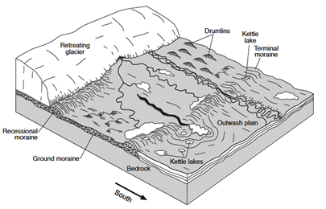

    - Running Water: causes the greatest changes to Earth’s landscape.
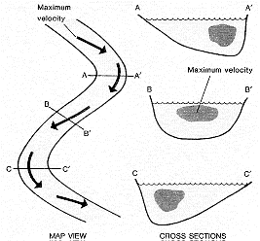
      - Gradient, discharge, and channel shape influence a stream’s velocity and the erosion and deposition of sediments.
        - Erosion occurs on the outside of a stream curve. Deposition occurs on the inside of a stream curve.
        - The size of sediments that can be transported by running water can be determined using the graph on ESRT page 6 – Relationship of Transported Particle Size to Water Velocity
      - Sediments transported by streams tend to become rounded as a result of abrasion.
      - Stream features include V-shaped valleys, deltas, flood plains, and meanders.
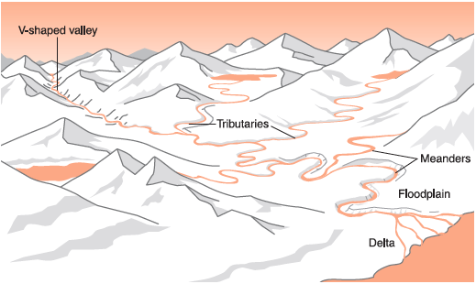
        - Deltas have horizontally sorted sediments because water velocity decreases when a stream enters a large body of water.
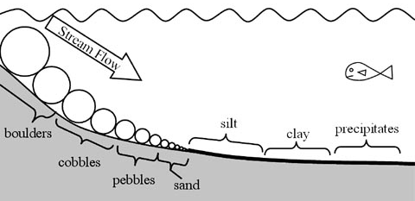
      - A watershed is the area drained by a stream and its tributaries.
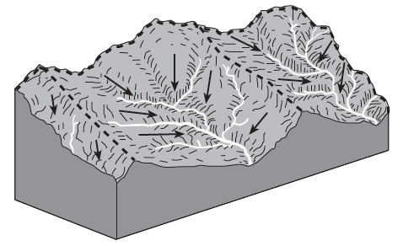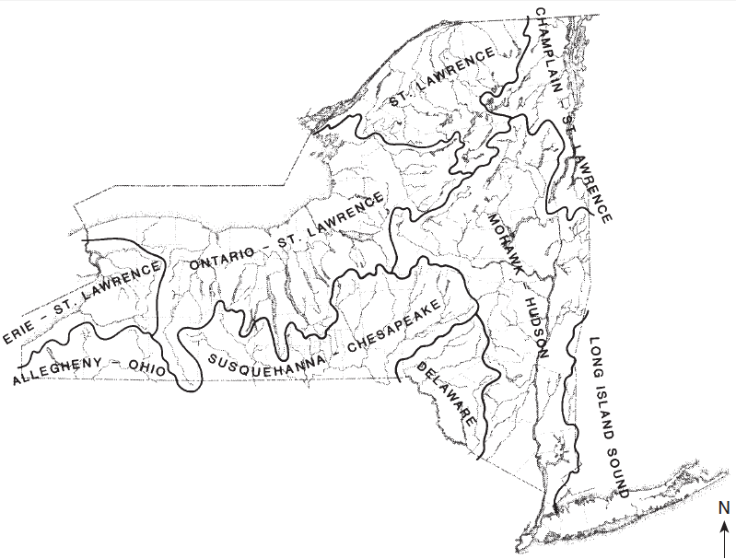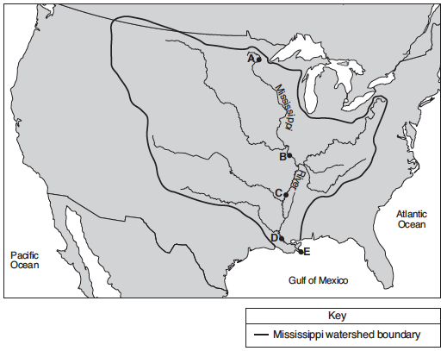
- Landscapes
  - Classification:
    - Mountains (highlands) have high elevation & tilted/faulted/folded bedrock
    - Plateaus (uplands) have high elevation & horizontal sedimentary layers
    - Plains (lowlands) have low elevation & horizontal sedimentary layers
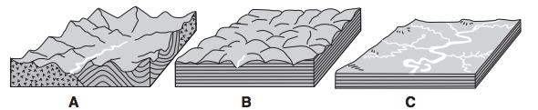
  - NYS Landscape Regions are found on ESRT page 2.
  - Climate:
    - Humid climates have rounded lands with a lot of vegetation.
    - Arid climates have sharp, angular land with little vegetation.
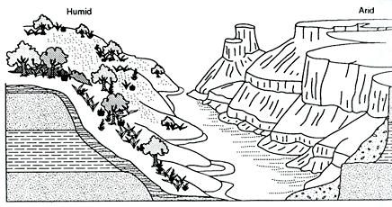

  - Stream drainage pattern are dependent on bedrock structure.
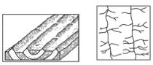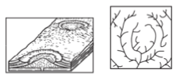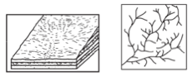

Regents Review #6
Surface Processes

Practice Regents Questions

- Which two cities are located in the Interior Lowlands?
(1) Elmira and Binghamton (3) Massena and Old Forge
(2) Riverhead and New York City (4) Buffalo and Watertown

- Evidence that glaciers covered large areas of New York State is best provided by
(1) long-term temperature measurements (3) kettle lakes and drumlins
(2) folded layers of bedrock (4) the presence of streams and rivers

- Trees growing on the edge of a river’s meander are most likely to fall into the river due to
(1) deposition on the inside of the meander
(2) deposition on the outside of the meander
(3) erosion on the inside of the meander
(4) erosion on the outside of the meander

- What is the approximate minimum stream velocity needed to keep a 0.2-cm-diameter particle in motion?
(1) 10 cm/s (2) 50 cm/s (3) 100 cm/s (4) 200 cm/s

- The photograph below shows a sandstone butte in an arid region.
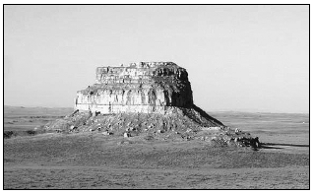
Which agents of erosion are currently changing the appearance of this butte?
(1) glaciers and mass movement (3) wind and mass movement
(2) wave action and running water (4) running water and glaciers

- Sediment is deposited in a river delta because the
(1) velocity of the river decreases (3) volume of the river increases
(2) force of gravity decreases (4) gradient of the river increases

- A landslide is an example of
(1) river deposition (2) glacial scouring (3) mass movement (4) chemical weathering

- Each of the rock particles below has the same density and volume. Which particle will most likely settle at the fastest rate in moving water?
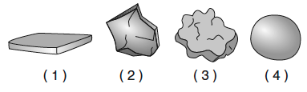
- Which rock weathers most rapidly when exposed to acid rain?
(1) quartzite (2) granite (3) basalt (4) limestone

- What is the approximate minimum stream velocity needed to keep a particle in motion that has a diameter of 10 centimeters?
(1) 110 cm/s (2) 190 cm/s (3) 325 cm/s (4) 425 cm/s

- Which change is most likely to occur in a landscape if its climate changes from humid to arid?
(1) Wind will become a more important agent of erosion.
(2) Surface features will become more rounded.
(3) Chemical weathering will increase.
(4) Vegetation will increase.

- The surface bedrock in the Hudson Highlands consists mostly of
(1) diabase, dolostone, and granite
(2) slate, siltstone, and basalt
(3) gneiss, quartzite, and marble
(4) limestone, shale, sandstone, and conglomerate

- The Catskills landscape region is classified as a plateau because it has
(1) low elevations and mostly faulted or folded bedrock
(2) low elevations and mostly horizontal bedrock
(3) high elevations and mostly faulted or folded bedrock
(4) high elevations and mostly horizontal bedrock

- Landscapes characterized by gentle slopes and meandering streams are most often found in regions with
(1) steep mountain cliffs (3) recently active faults and folds
(2) sediment-covered bedrock (4) high volcanic activity

- The photograph below shows a valley.
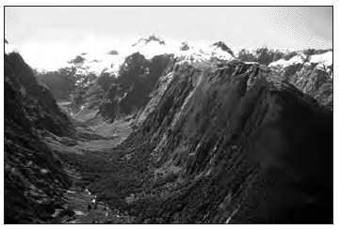
Which agent of erosion most likely produced this valley’s shape?
(1) blowing wind (2) ocean waves (3) moving ice (4) running water

- Pieces of bedrock material that are broken from a cliff and deposited by a landslide at the base of the cliff are best described as
(1) rounded and sorted (3) angular and sorted
(2) rounded and unsorted (4) angular and unsorted

- Sandstone, limestone, and conglomerate cobbles are found in a streambed in New York State where the surrounding bedrock is composed of shales and siltstones. The most likely explanation for the presence of these cobbles is that they were
(1) weathered from the surrounding bedrock
(2) formed when shale and siltstone bedrock were eroded
(3) transported to this area from another region
(4) metamorphosed from shale and siltstone

- The narrow, sandy, barrier islands in the ocean along the south coast of Long Island were deposited by
(1) wind (2) streams (3) glacial ice (4) wave action

- The map below shows a stream drainage pattern. Arrows show the direction of stream flow.
On which landscape region did this drainage pattern most likely develop?

Base your answers to questions 20 through 22 on the map below and on your knowledge of Earth science. The map shows the location of Sandy Creek, west of Rochester, New York. X and Y represent points on the
banks of the stream.
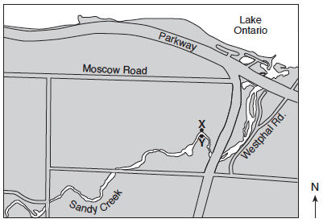
- Draw a line to represent the shape of the stream bottom from point X to point Y.

- Explain why sediments are deposited when Sandy Creek enters Lake Ontario.

- The symbols representing four sediment particles are shown in the key in your answer booklet. These particles are being transported by Sandy Creek into Lake Ontario. On the cross section below, draw the symbols on the bottom of Lake Ontario to show the relative position where each sediment particle is most likely deposited.
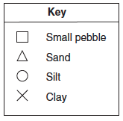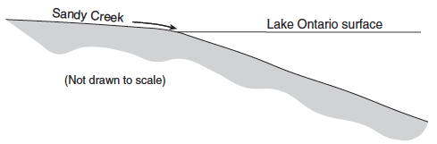

Base your answers to questions 23 through 25 on the map below and on your knowledge of Earth science. The map shows a retreating valley glacier and the features that have formed because of the advance and retreat of the glacier.

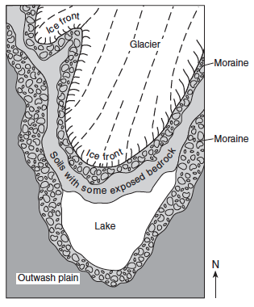

- Describe one piece of evidence likely to be found on the exposed bedrock surfaces that could indicate the direction this glacier moved.

- Describe one difference between the arrangement of sediment in the moraines and the arrangement of sediment in the outwash plain.

- Describe the most likely shape of the valley being formed due to erosion by this glacier.

Regents Review #6
Surface Processes

Practice Regents Questions – Answer Key

- 4 (See ESRT pages 2 and 3)
- 3 (See Fact 24,c,iv)
- 4 (See Fact 24c,v,1)
- 1 (See ESRT page 6 – Stream Velocity)
- 3 (See Fact 24c,i and 24c,ii)
- 1 (See Fact 24c,v,3,a)
- 3 (See Fact 24c,i)
- 4 (See Fact 24b)
- 4 (See Fact 23a)
- 2 (See ESRT page 6 – Stream Velocity)
- 1 (See Fact 24c,ii)
- 3 (See ESRT page 2 and 3)
- 4 (See Fact 25a)
- 2 (See Fact 24c,v,3)
- 3 (See Fact 24c,iv)
- 4 (See Fact 24c,i)
- 3 (See Fact 24c,v)
- 4 (See Fact 24c,iii)
- 3 (See Fact 25d)
- Allow 1 credit for a streambed that is deeper near the X. (See Fact 24c,v,1)
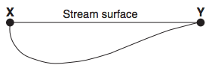
- Water velocity decreases when a stream enters a large body of water. (See Fact 24c,v)
- Allow 1 credit if the relative positions of the symbols or particle names are in the order shown.
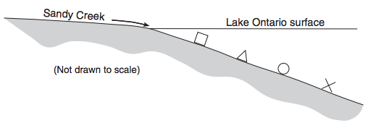
- Scratches; grooves; drumlins; erratics (See 24c,iv)
- Moraine has unsorted, unlayered sediments. Outwash plain has sorted, layered sediments. (See Fact 24c,iv)
- U-shaped (See Fact 24c,iv)

