Earth Science
Regents Review #5
Rocks & Minerals
© Kaitlin Coder
https://www.teacherspayteachers.com/Store/Nys-Earth-Science-And-Living-Environment-Regents
Topics Reviewed:
Minerals
Rock Cycle
Igneous Rocks
Sedimentary Rocks
Metamorphic Rocks

PLUS 22 Regents Questions with Answers!
Regents Review #5
Rocks & Minerals

- Minerals

  - Mineral properties depend on internal arrangement of the atoms (color, streak, hardness, luster, cleavage & fracture). (ESRT page 16)
    - Streak: color of a mineral’s powder
    - Hardness: ability for a mineral to scratch or be scratched
    - Luster: how a mineral reflects light
      - Metallic: looks like a metal
      - Non-metallic: does not look like a metal
    - Cleavage: mineral breaks with at least one flat surface
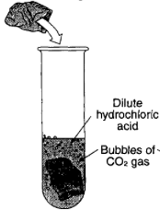
    - Fracture: mineral breaks in an uneven, jagged manner
  - Calcite bubbles with acid. Rocks made of calcite (marble, limestone & dolostone) also bubble.

- Rocks

  - Rocks are composed of one or more minerals.
    - Rocks are classified by their origin, mineral content, and texture.
    - Rock Cycle: diagram showing how each rock type is formed (ESRT p6 Rock Cycle)

  - Igneous rocks form when magma or lava cools and solidifies. (ESRT p6 Igneous Rocks)
    - Crystal size indicates the amount of time it took for the rock to form.
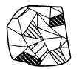
      - Small or no crystals formed quickly near Earth’s surface (extrusive).
      - Large crystals formed slowly underneath Earth’s surface (intrusive).

    - Mineral composition affects the color and density of igneous rocks.
      - Felsic rocks are composed of silicon and aluminum, have light colors and low densities.
      - Mafic rocks are composed of iron and magnesium, have dark colors and high densities.

  - Sedimentary rocks: are deposited in horizontal layers and may contain fossils (ESRT p7)
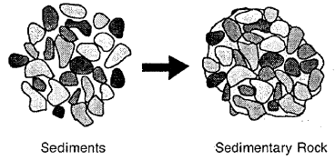
    - Clastic (fragmental) sedimentary rocks form when sediments are compacted and/or cemented after burial
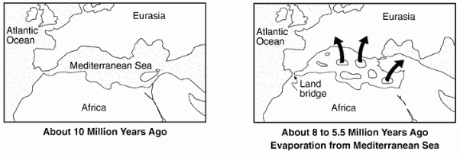
    - Crystalline (chemical) sedimentary rocks form as the result of chemical precipitation from seawater.

    - Bioclastic (organic) sedimentary rocks form from the accumulation of plant and animal remains

  - Metamorphic rocks: formed when rocks undergo intense heat and pressure (ESRT p7)
    - Causes rocks to recrystallize, increase in density, and become distorted.
    - Foliated metamorphic rocks have mineral alignment. Non-foliated metamorphic rocks do not have mineral alignment.
      - Banding metamorphic rocks have alternating light colors and dark colors.
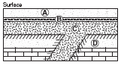
    - Contact metamorphism occurs when molten rock comes into contact with surrounding rock in a small area

    - Regional metamorphism occurs when large areas of rock undergo intense heat and pressure; associated with mountain building
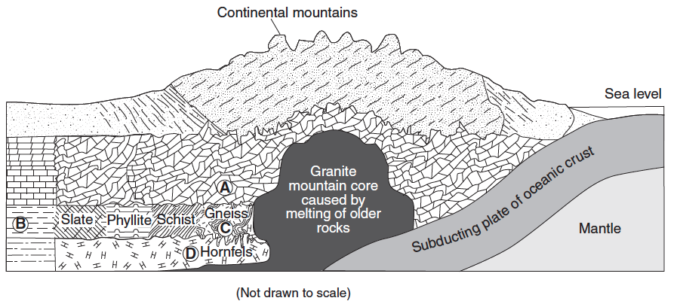
Regents Review #5
Rocks & Minerals

Practice Regents Questions

- The table below lists some information about the minerals graphite and diamond.
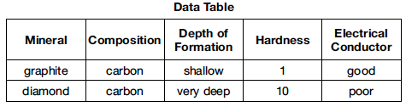
Some properties of diamond are different from those of graphite because diamond
(1) has a different arrangement of atoms (3) has a different composition
(2) forms larger crystals (4) is older in geologic age

Base your answers to questions 2 and 3 on the data table below and on your knowledge of Earth science. The table provides information about four minerals, A through D.

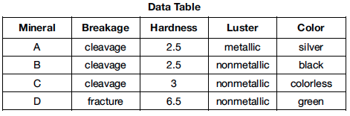

- The diagram below represents a sample of mineral A.
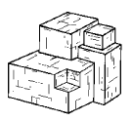
Mineral A is most likely
(1) garnet (2) galena (3) olivine (4) halite

- Which mineral can scratch A, B, and C, but can not scratch D?
(1) talc (2) quartz (3) dolomite (4) selenite gypsum

- The graph below shows the hardness of four minerals.
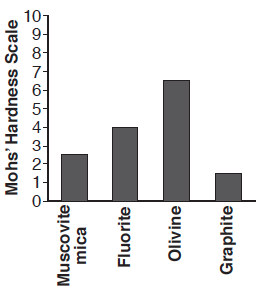
Which mineral is hard enough to scratch calcite but is not hard enough to scratch amphibole?
(1) muscovite mica (2) fluorite (3) olivine (4) graphite

- Which two properties are most useful in distinguishing between galena and halite?
(1) cleavage and color (3) hardness and streak
(2) luster and color (4) streak and cleavage

- Which processes lead directly to the formation of igneous rock?
(1) weathering and erosion (3) heat and pressure
(2) compaction and cementation (4) melting and solidification

- The data table below lists characteristics of rocks A, B, C, and D.
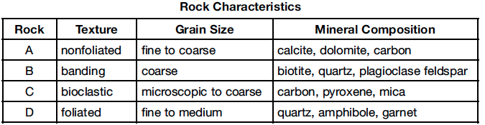
Which rock is most likely phyllite?
(1) A (2) B (3) C (4) D

- Most of the sediment that is compacted and later forms shale bedrock is
(1) clay (2) silt (3) sand (4) pebbles

Base your answers to questions 9 and 10 on the diagram below, which represents a rock composed of cemented pebbles and sand.
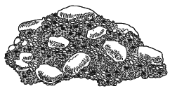
- This rock should be classified as
(1) an intrusive igneous rock (3) a bioclastic sedimentary rock
(2) an extrusive igneous rock (4) a clastic sedimentary rock

- Which change would most likely occur if this rock became buried deep within Earth’s crust and was subjected to intense heat and pressure, but did not melt?
(1) The density of the pebbles and sand would decrease.
(2) The rock would become a plutonic rock composed mostly of quartz.
(3) The rock would become more felsic with a higher concentration of magnesium.
(4) The pebbles would become distorted and the sand would be recrystallized.

Base your answers to questions 11 through 13 on the table and photograph below and on your knowledge of Earth science. The table shows the approximate mineral percent composition of an igneous rock. The photograph shows the true-scale crystal sizes in this igneous rock.
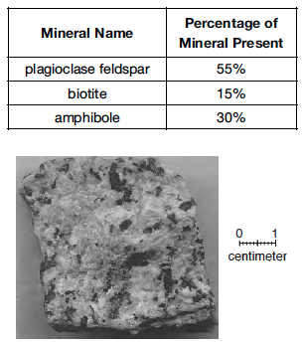
- Identify two elements that are commonly found in all three minerals in the data table.

- Identify this igneous rock.

- Identify two processes that formed this rock.

Base your answers to questions 14 through 16 on the diagram of Bowen’s Reaction Series below, which shows the sequence in which minerals crystallize as magma cools and forms different types of igneous rocks from the same magma. The arrow for each mineral represents the relative temperature range at which that mineral crystallizes.
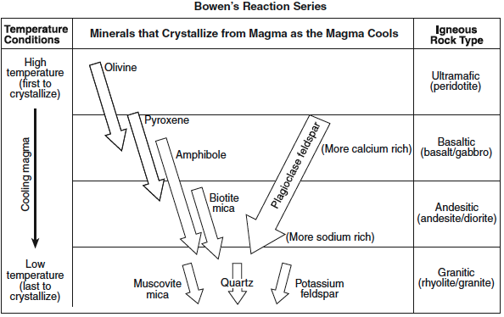

- According to Bowen’s Reaction Series, how is the chemical composition of plagioclase feldspar found in basaltic rock different from the chemical composition of plagioclase feldspar found in granitic rock?

- Describe the temperature conditions shown in Bowen’s Reaction Series that explain why olivine and quartz are not usually found in the same igneous rock type.

- Identify one similarity and one difference between the igneous rocks andesite and diorite.

Base your answer to questions 17 through 19 on the cross section below, which shows the bedrock structure of a portion of the lithosphere. Letters A through D represent locations in the lithosphere.

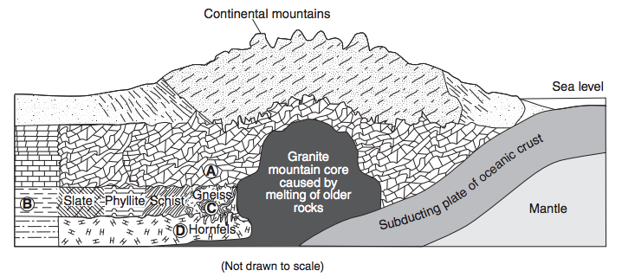

- Identify one of the most abundant minerals in the metamorphic rock at location A.

- Explain why the type of rock changes between locations B and C.

- Identify the grain size of the metamorphic rock at location D.

Base your answer to questions 20 through 22 on the cross section below, which shows rock units A through E that have not been overturned.

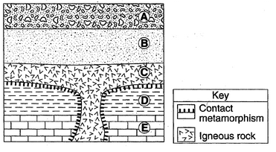

- State the diameter of a particle normally found in rock unit B.

- Identify one metamorphic rock that may be found along the boundary between rock units C and E.

- Identify two processes that formed rock unit A from sediment.

Regents Review #5
Rocks & Minerals

Practice Regents Questions – Answer Key

- 1 (See Fact 21a)
- 2 (See Fact 21a and ESRT page 16)
- 3 (See Fact 21a,ii and ESRT page 16)
- 2 (See Fact 21a,ii and ESRT page 16)
- 2 (See Fact 21a and ESRT page 16)
- 4 (See ESRT page 6 – Rock Cycle)
- 4 (See ESRT page 7 – Metamorphic Rocks)
- 1 (See ESRT page 7 – Sedimentary Rocks)
- 4 (See ESRT page 7 – Sedimentary Rocks)
- 4 (See Fact 22d,i and ESRT page 6 – Rock Cycle)
- Oxygen; Silicon; Aluminum (See ESRT page 16)
- Diorite (See ESRT page 6 – Igneous Rocks)
- Melting and solidification (See ESRT page 6 – Rock Cycle)
- Basaltic rock is more calcium rich while granitic rock is more sodium rich. (Refer to diagram)
- Olivine crystallizes at high temperatures while quartz crystallizes at low temperatures. (Refer to diagram)
- Similarities: color, density, composition. Differences: crystal size, texture, environment of formation (See ESRT page 6 – Igneous Rocks)
- Calcite; dolomite (See ESRT page 7 – Metamorphic Rocks)
- Regional metamorphism (See ESRT page 7 – Metamorphic Rocks)
- Fine (See ESRT page 7 – Metamorphic Rocks)
- 0.006 – 0.2 cm (See ESRT page 7 – Sedimentary Rocks)
- Marble; hornfels (See ESRT page 7 – Sedimentary Rocks AND Metamorphic Rocks)
- Burial; deposition; compaction; cementation (See ESRT page 6 – Rock Cycle)

