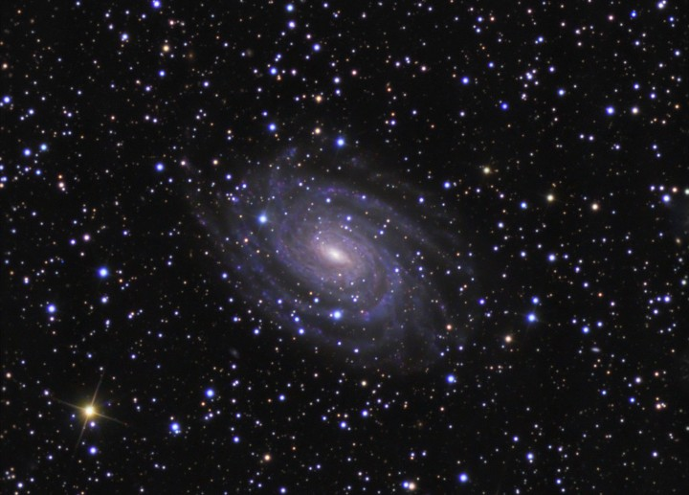
© Kaitlin Coder 2015
https://www.teacherspayteachers.com/Store/Nys-Earth-Science-And-Living-Environment-Regents
Earth Science
Regents Review #1
Prologue & Earth Dimensions

Topics Reviewed:
Interactions in Nature
Graphing & Relationships
Density
Earth’s Shape & Earth’s Spheres
Latitude & Longitude
Isolines
Topographic Maps

PLUS 25 Practice Regents Questions with Answers!

Regents Review #1
Prologue & Earth Dimensions

- Interactions in Nature
  - An observation uses your senses. An instrument extends your senses.
  - An inference (prediction) is a conclusion based on observations.
  - Classification is grouping by observable properties.
  - An interface is a boundary across which energy is exchanged

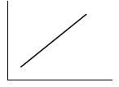
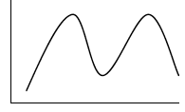
- Graphing & Relationships
  - Graphing a direct relationship, as X-axis (independent variable) increases, Y-axis (dependent variable) increases.
  - Graphing an indirect relationship, as X-axis increases, Y-axis decreases.
  - Graphing a static relationship, as X-axis increases, Y-axis stays the same.
  - Most environmental changes are cyclic and predictable (ex: tides, moon phases)

- Density
  - Density: how tightly packed molecules are in a substance
  - The same substance always has the same density at the same temperature, no matter how many pieces you break it in to.
  - As pressure increases, density increases.

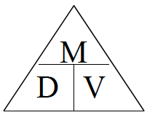
  - As temperature increases, density decreases.

  - Density can be calculated using equation D=M/V (see ESRT page 1)
  - Water expands when it freezes (other substances contract).
    - Water is most dense at 4˚C, when it is a liquid. (see ESRT p1)
    - Anything with a density greater than 1.0g/cm³ will sink in water.

- Earth’s Shape
  - The true shape of the Earth is an oblate sphere (slightly flattened at the poles and slightly wider at the equator).
    - Evidences that the Earth is round are: 1) “sinking ship” observation; 2) photographs from space; 3) Earth’s shadow on the Moon; 4) stars shift relative to the horizon as you move North and South
  - Earth’s 3 spheres: lithosphere (solid rock), hydrosphere (water), atmosphere (gases)
  - ESRT Pages to Know:
    - Page 1: Average Chemical Composition of Earth’s Crust, Hydrosphere, & Troposphere
    - Page 10: Inferred Properties of Earth’s Interior
    - Page 14: Selected Properties of Earth’s Atmosphere
- Latitude, Longitude, Polaris, & Time
  - Latitude lines measure distances North or South of the equator.
    - Latitude is expressed as 0° - 90° North or South.
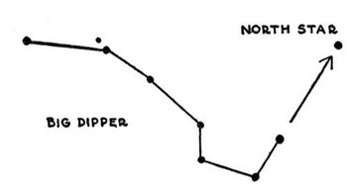
  - The altitude of Polaris (the North Star) equals your latitude in the Northern Hemisphere.
    - Polaris is located directly above Earth’s North Pole. If you are facing Polaris, you are facing due north.
    - Altitude of Polaris is an angle in degrees only (do not write direction!)
    - Use the pointer stars on the Big Dipper to find Polaris.
    - Polaris cannot be seen in the Southern Hemisphere.
  - Longitude lines measure distances East or West of the Prime Meridian.
    - Longitude is expressed as 0° - 180° East or West of the Prime Meridian (0°). (180° = the International Dateline).
  - Longitude is based on observations of the sun (position & time).
    - The Earth rotates on its axis from west to east at a rate of 15° per hour (360° ÷ 24 hours).
    - As you go East, time will Increase.
    - As you go West, time will get less.
  - ESRT pages to know: Maps on Pages 3, 4, 5 (for Latitude & Longitude)

- Isolines
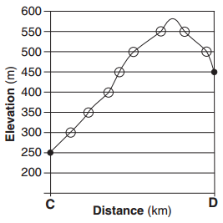
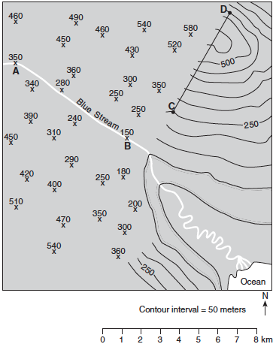
  - Measuring on a map: Use a piece of scrap paper and the map scale to measure distance on a map.

  - Isolines connect equal values. Isolines never cross and must either connect back to itself in a circle or run off of the map.
  - Contour lines connect equal elevations.
    - The contour interval tells you how much each line increases by.
    - The contour line next to the ocean always has a value of zero.
  - Gradient: how quickly a field value changes over a distance
    - The closer the isolines, the steeper the slope or gradient. The farther the isolines, the more gentle the slope or gradient.
    - Gradient can be mathematically calculated (use ESRT page 1 equation).
  - River flow: Contour lines point in the opposite direction of the stream flowing across them. “V’s point upstream.” (Blue Stream is flowing southeast because contour lines are pointing northwest.)
  - The highest possible elevation one less than the value the next contour line would be. The lowest possible elevation is one greater than the value the lower contour line would be.
  - Profile: the side view of the map (see profile of line CD above).
  - Hachured lines: indicate a depression. Each hachured line decreases by the contour interval.
  - ESRT Pages to Know: Page 1: Equations (Gradient & Rate of Change)

Regents Review #1
Prologue/Earth Dimensions

Practice Regents Questions

Base your answers to questions 1 and 2 on the data table below, which shows the amount of water vapor, in grams per cubic meter, that will saturate 1 cubic meter of air at different temperatures.

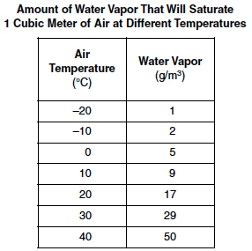
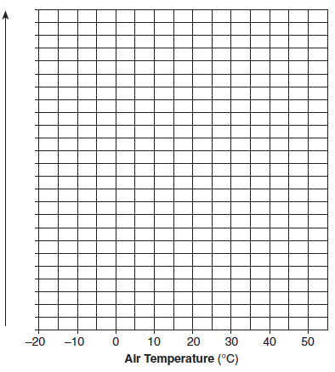

- On the grid provided in your answer booklet, construct a line graph of the data, following the directions below.
  - Place the name of the correct variable along the y-axis. Include the correct units.
  - Mark an appropriate numerical scale showing equal intervals along the y-axis.
  - Plot the amount of water that will saturate 1 cubic meter of air at the temperatures shown in the data table. Connect the points with a smooth, curved line.

- Describe the relationship between the air temperature and the amount of water vapor necessary to saturate the air.

- The graph below shows the tidal changes in ocean water level, in meters, recorded at a coastal location on a certain day.
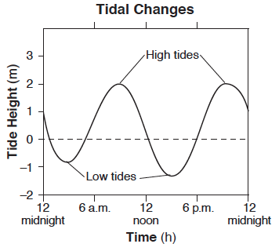
Approximately how many hours apart were the two high tides?
(1) 6 h (2) 12 h (3) 18 h (4) 24 h

- As air on the surface of Earth warms, the density of the air
(1) decreases (2) increases (3) remains the same

- In the first picture, the sphere is in a beaker with 100 mL of water. In the second picture, the mass of the dry sphere is being taken. Which of the values listed is closest to the density of the black sphere?
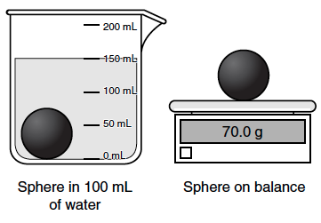
(1) 0.5 g/mL (2) 0.7 g/mL (3) 1.4 g/mL (4) 2.1 g/mL

- The graph below shows the relationship between mass and volume for three samples, A, B, and C, of a given material.
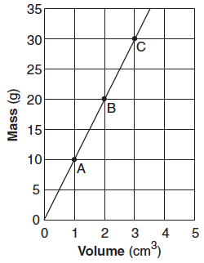
What is the density of this material?
(1) 1.0 g/cm³ (2) 5.0 g/cm³ (3) 10.0 g/cm³ (4) 20.0 g/cm³
- In which two Earth regions is oxygen the second most abundant element by volume?
(1) crust and hydrosphere (3) troposphere and core
(2) hydrosphere and troposphere (4) core and crust

- What is the inferred pressure, in millions of atmospheres, in Earth’s interior at a depth of 2900 kilometers?
(1) 1.4 (2) 9.9 (3) 3.0 (4) 4900

- At what approximate altitude in the atmosphere can stratospheric ozone be found?
(1) 10 km (2) 30 km (3) 70 km (4) 100 km

- The diagram below represents Earth at one position in its orbit around the Sun. Starting at the North Pole, draw a straight arrow that points to the location of Polaris.

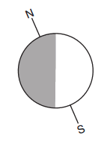

- The diagram below shows an observer on Earth measuring the altitude of Polaris
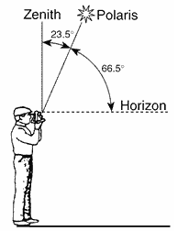
What is the latitude of this observer?
1) 90˚N 2) 66.5˚N 3) 43˚N 4) 23.5˚N

- Which graph best represents the relationship between the latitude of an observer and the observed altitude of Polaris above the northern horizon?
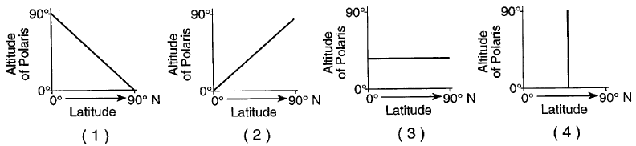
- At which New York State location will an observer most likely measure the altitude of Polaris as approximately 42˚?
1) Jamestown 2) Plattsburgh 3) Oswego 4) New York City

- The map below shows four locations, A, B, C, and D, on the continent of South America.
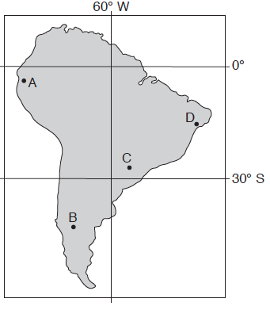
Which location is the first to experience sunset on September 23?
(1) A (2) B (3) C (4) D

- The map below shows a portion of the Middle East. Points A, B, C, D, and X are locations on Earth’s surface.
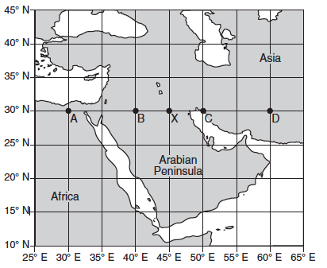
When it is 10:00 a.m. solar time at location X, at which location is 11:00 a.m. solar time being observed?
(1) A (2) B (3) C (4) D

- Which latitude and longitude coordinates represent a location on the continent of Australia?
(1) 20º N, 135º E (3) 20º S, 135º E
(2) 20º N, 135º W (4) 20º S, 135º W

- What is the approximate location of the Canary Islands?
1) 32˚S, 18˚W 2) 32˚S, 18˚E 3) 32˚N, 18˚W 4) 32˚N, 18˚E

Base your answers to questions 18 through 21 on the topographic map below and on your knowledge of Earth science. Points A, B, C, and D represent locations on the surface of Earth. Elevations are measured in feet.
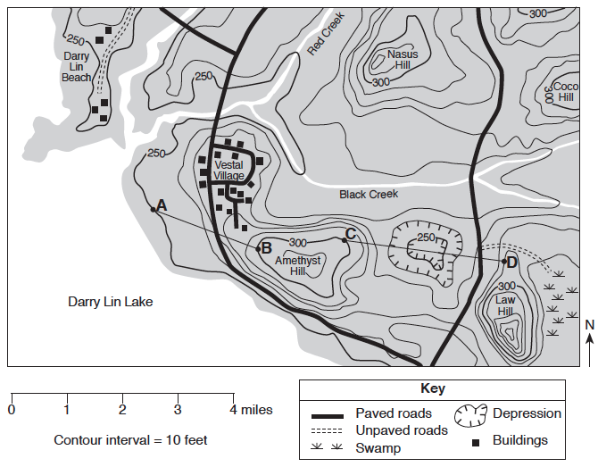
- What is the approximate gradient from point A to point B on the map?
(1) 25 feet per mile (2) 50 feet per mile (3) 75 feet per mile (4) 100 feet per mile

- In which general direction does Red Creek flow?
(1) northeast (2) southeast (3) southwest (4) northwest

- What is a possible elevation for the surface of Darry Lin Lake?
(1) 228 feet (2) 242 feet (3) 255 feet (4) 268 feet

- Which cross section represents an accurate profile of the landscape between points C and D?
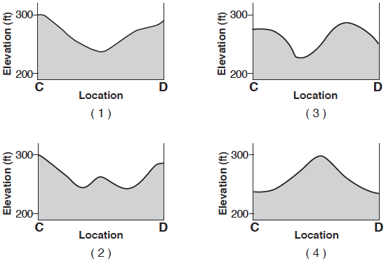
Base your answers to questions 22 through 25 on the field map below and on your knowledge of Earth science. The map shows the depth of Lake Ontario. Isoline values indicate water depth, in feet. Points A, B, and C represent locations on the shoreline of Lake Ontario. Points D and E represent locations on the bottom of the lake.
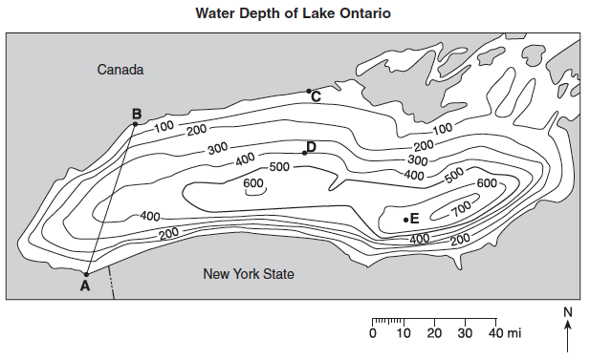

- What is a possible depth of the water at location E?

- What evidence shown on the map indicates that the southern section of the bottom of Lake Ontario has the steepest slope?

- On the grid in your answer booklet, draw a profile of the bottom of western Lake Ontario by plotting the depth of the water along line AB. Plot each point where an isoline showing depth is crossed by line AB. Connect the plots with a line, starting at A and ending at B, to complete the profile.
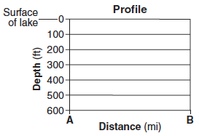
- A raft was set off in Lake Ontario at point C. It took 30 minutes to reach point D. Calculate the rate of movement across the lake surface from point C to point D. Label your answer with the correct units.

Regents Review #1
Prologue/Earth Dimensions

Practice Regents Questions – Answer Key

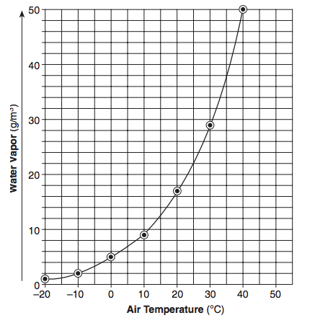

- Direct relationship: As air temperature increases, the amount of water vapor that the air could hold increases. (See Fact 2a)
- 2 (See Fact 2d)
- 1 (See Fact 3d)
- 3 (See Fact 3e)
- 3 (See Fact 3e)
- 2 (See Fact 4c,i & ESRT p1)
- 1 (See Fact 4c,ii & ESRT p10)
- 2 (See Fact 4c,iii & ESRT p14)
- (See Fact 5b,i)

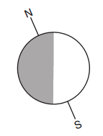
- 2 (See Fact 5b)
- 2 (See Fact 5b)
- 1 (See Fact 5b & ESRT p3)
- 4 (See Fact 5d,ii)
- 4 (See Fact 5d,i & 5d,ii)
- 3 (See Fact 5e & ESRT p4)
- 3 (See Fact 5e ESRT p5)
- 1 (See Fact 6d,ii)
- 3 (See Fact 6e)
- 2 (See Fact 6f)
- 1 (See Fact 6g & 6h)
- Any depth from 601 to 699 feet (See Fact 6f)
- The isolines are closest together (See Fact 6d,i)
- (See Fact 6g)
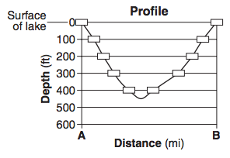
25. 0.67 mi/minute (See Fact 6i & ESRT p1)

